安裝postman

<https://drive.google.com/file/d/1czvHvWNE4vzawqiFhHfIyorWxrDzow3X/view?usp=sharing>

新增Collection

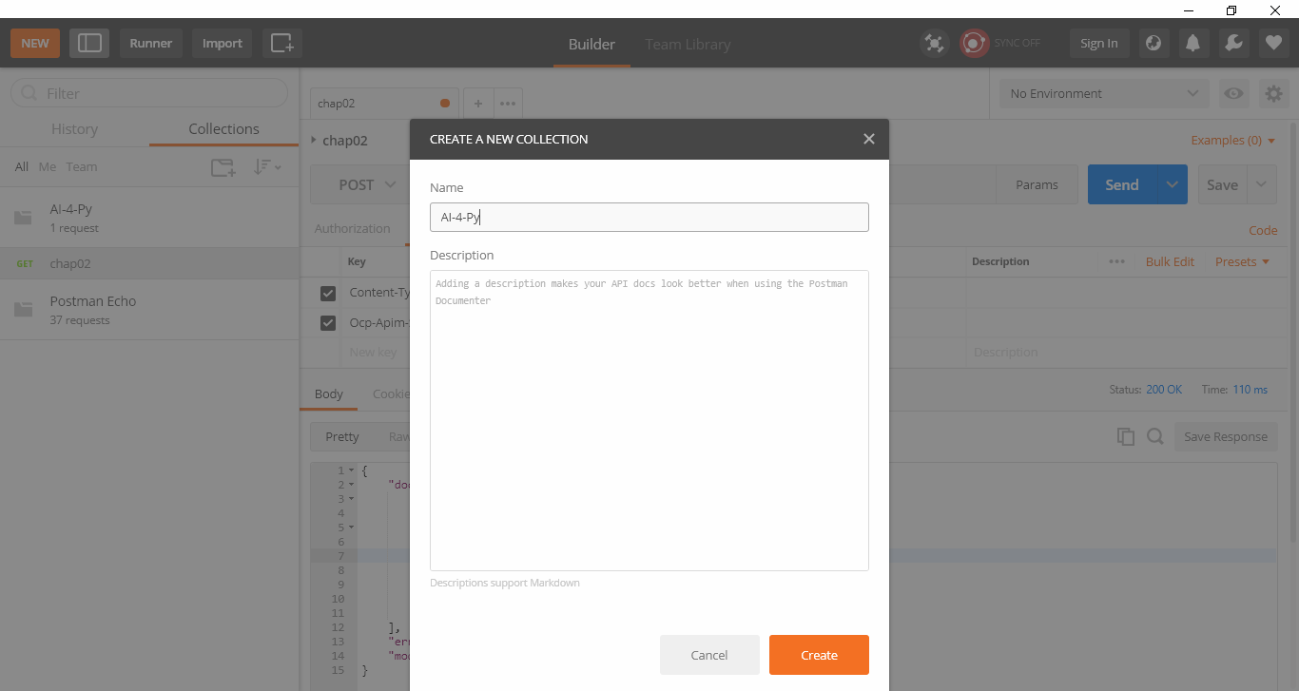

新增request

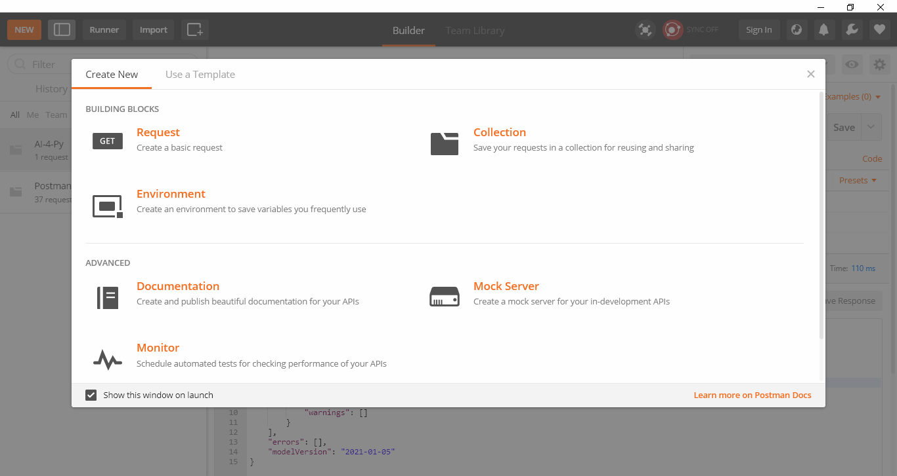指定request 🡪 collection

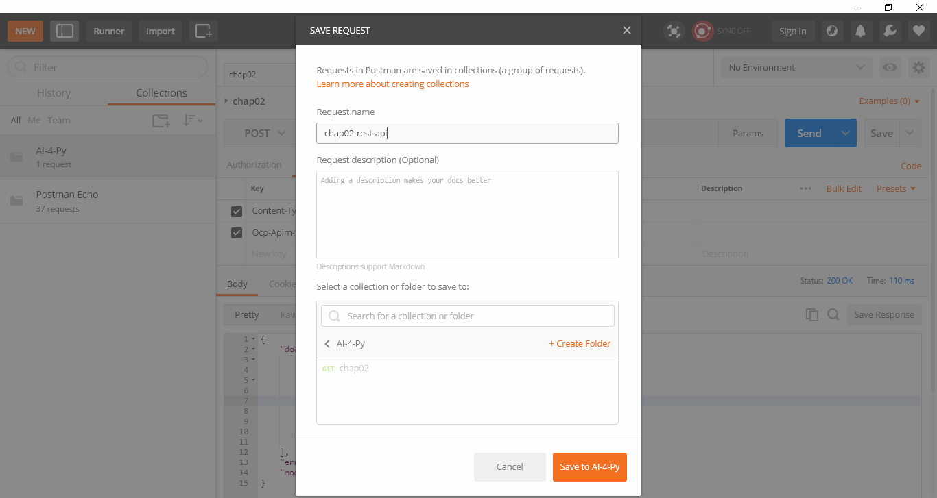

POST

<https://azml0608.cognitiveservices.azure.com/text/analytics/v3.1/languages>

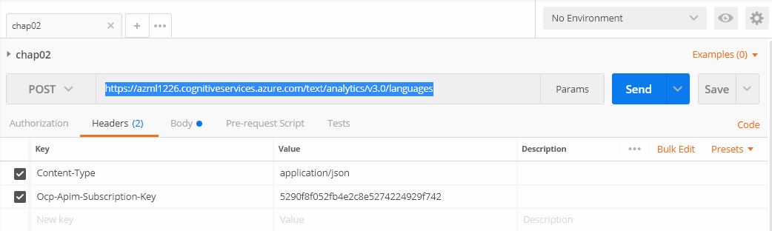

Content-Type application/json

Ocp-Apim-Subscription-Key d294986eff75428898f84f7d6b80f694

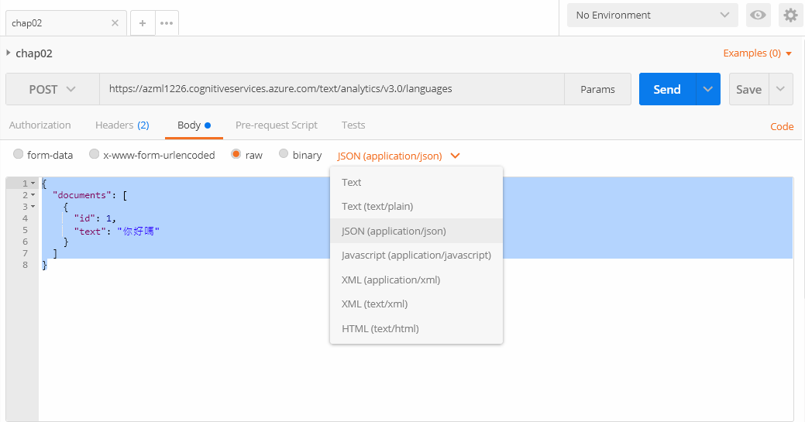

{

"documents": [

{

"id": 1,

"text": "你好嗎"

}

]

}

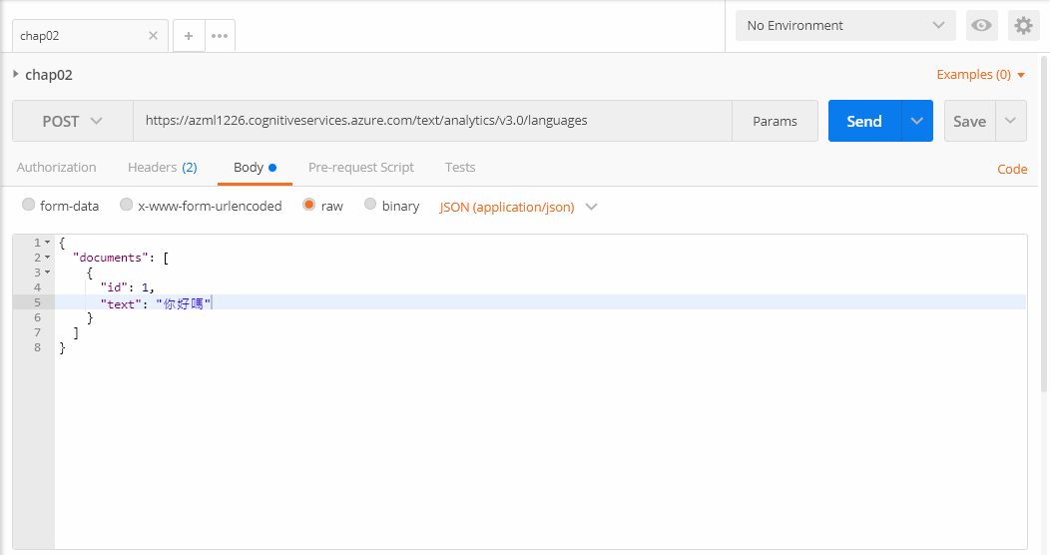

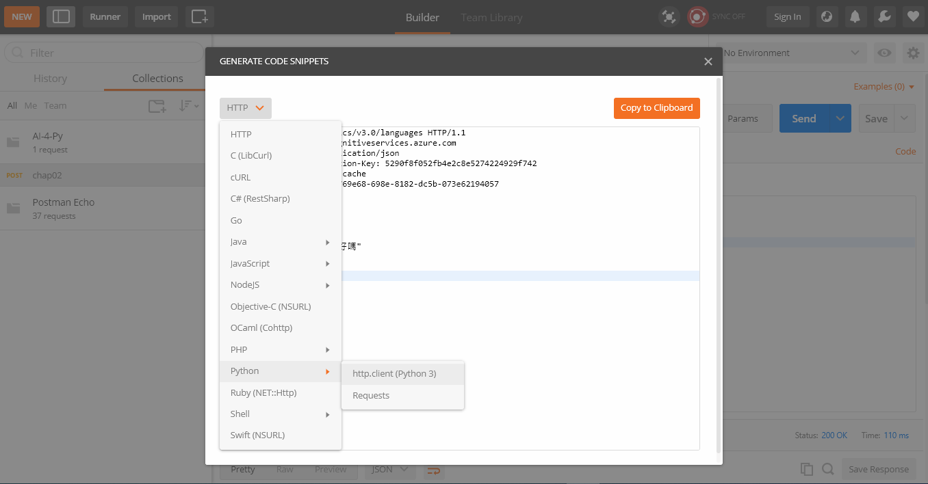

Code to Python

